Manchester Geological Association
The Arts Theatre, Samuel Alexander Building, University of Manchester
Saturday 17th January 2015 at 10.30am

The Broadhurst Lectures
The Mineral World

10.30 – 11.30 When Geomicrobiology meets Ionising Radiation
Ashley Brown, SEAES, University of Manchester

11.30 – 12.30 Minerals and Gems of the Cairngorms
Roy Starkey, The Russell Society

12.30 – 13.45 Lunch Break

13.45 – 14.45 From Fluorite to Fluid Flow – an exploration of some iconic Northern Pennine Minerals
Dr Brian Young, Honorary Research Fellow, Department of Earth Sciences, University of Durham

14.45 – 15.45 The World Class Copper Deposits of Chile - Geology, Exploration and Discovery
Dr. Chris Carlon, Mineral Industry Consultant

When Geomicrobiology meets Ionising Radiation
Ashley R. Brown
Williamson Research Centre for Molecular Environmental Science and School of Earth, Atmospheric and Environmental Sciences, University of Manchester

Biogeochemical processes mediated by Fe(III)-reducing bacteria have the potential to impact on the post-closure evolution of a geological disposal facility (GDF) for radioactive waste. However, the organisms promoting these processes will likely be subject to significant radiation fluxes. Therefore, the impact of acute doses of ionizing radiation on the physiological status of the model Fe(III)-reducing bacterium Shewanella oneidensis has been assessed, revealing Fe(III)-reduction.
The impact of radiation on the extracellular environment was also assessed. Exposure to gamma radiation caused activation of the Fe(III)-oxides ferrihydrite and hematite for enzymatic reduction by S. oneidensis. TEM, SAED and Mössbauer spectroscopy revealed that this effect was a result of radiation induced changes to crystallinity leading to an increase in bioavailability of Fe(III) for respiration.
To assess the impact of radiation on sediment microbial communities, a series of microcosm experiments were constructed and gamma irradiated over a two month period. Sediments irradiated at a dose rate of 0.5 Gy h-1 exhibited enhanced Fe(III) reduction despite receiving doses potentially lethal to indigenous microorganisms, whilst biogeochemical processes in sediments irradiated with 30 Gy h-1 were only partially restricted. Despite this, 16S rRNA gene pyrosequencing revealed significant dose-dependent shifts in the microbial communities in tandem with changes in microcosm biogeochemical profiles.
Collectively, these results indicate that, despite significant total absorbed doses, biogeochemical processes will likely not be restricted by dose rates expected in a deep geological repository. Indeed, microbial processes in such environments may even be stimulated by radiation

Minerals and Gems of the Cairngorms
Roy Starkey
The Russell Society

The Cairngorms are the most extensive area of high mountain terrain in Britain. The area has given its name to gem quality smoky quartz, but has also produced spectacular specimens of beryl and topaz. In Victorian times, hunting for crystals was both a popular pastime and a
“cottage industry”, but nowadays the area is a National Park and few fine specimens have come to light in recent years. In 1811 it was reported that these “Cairngorm Stones” were so much sought after, that a number of the inhabitants, not only of Aberdeenshire, but of the counties of Perth and Inverness, flocked to these mountains, in whole families, during the summer season, in quest of gems; and purchasers from London, who were well acquainted with their value, came frequently to buy the precious stones from these poor people. The profits of the finders or miners were extremely variable because the success rate was relatively low. Huge amounts of effort were expended in the search and records suggest that by the early 1800s, the Cairngorm diggers had already trenched more than twenty acres to a depth of from five to six feet. It is a recorded fact that Queen Victoria ascended Beinn a’ Bhuird on 6 September 1850 and collected specimens of | 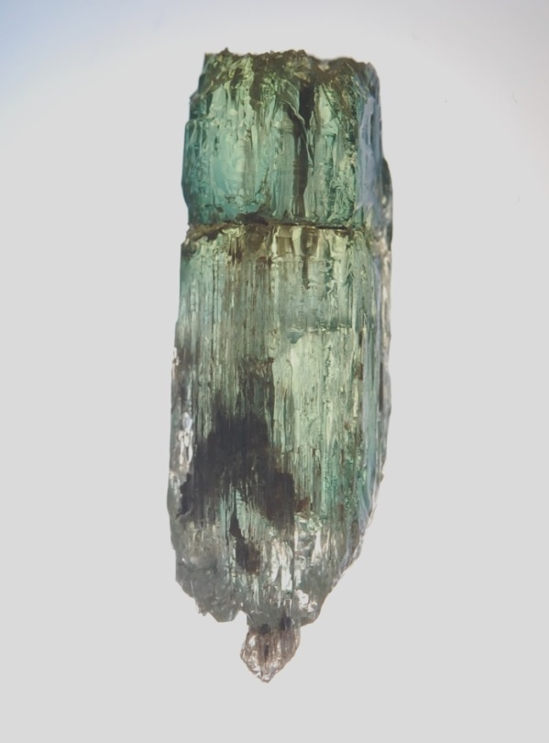
 | Smoky Quartz
Cairngorm quartz. This talk will review the fascinating history of “Cairngorm stones”, illustrated by images of notable specimens and explorations over the past 25 years or so.

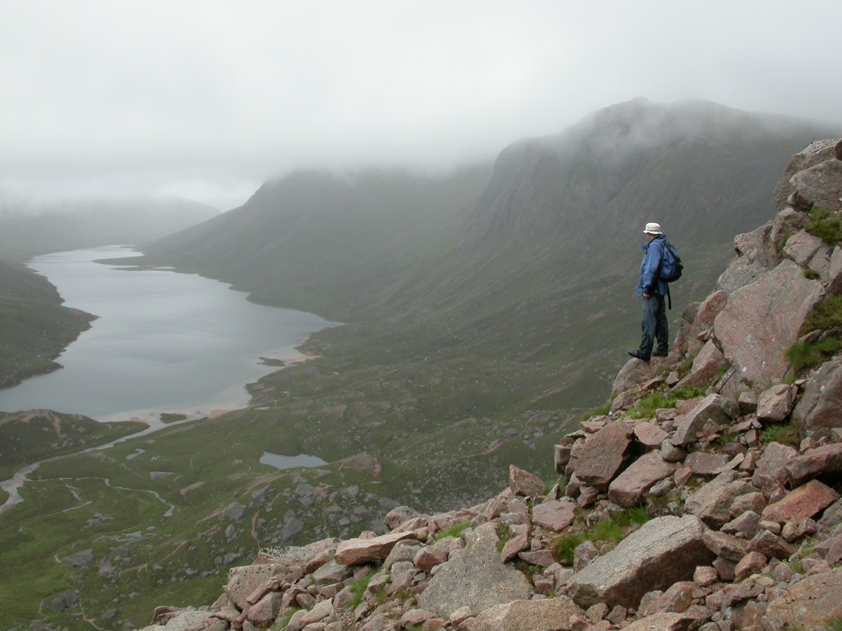
Loch Avon on a misty day with JF
From Fluorite to Fluid Flow – an exploration of some iconic Northern Pennine Minerals
Dr Brian Young
Honorary Research Fellow, Department of Earth Sciences, University of Durham

Over many centuries of metalliferous mining, the hills and dales of the Northern Pennines have become internationally celebrated both for exceptionally beautiful examples of many minerals and for the important insights these have provided into the origins of similar ore deposits worldwide. The Northern Pennine Orefield is an established ‘classic’ example of its type. This talk will explore examples of some of the area’s most spectacular and rare minerals and look at how these continue to shed light on the origins and evolution of the deposits of which they form part.

The World Class Copper Deposits of Chile - Geology, Exploration and Discovery
Dr. Chris Carlon
Mineral Industry Consultant

Chile produces one third of the total global copper output and accounts for one third of the known reserves. It hosts some of the largest copper deposits and mines in the world including
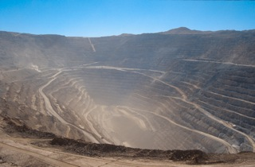 | La Escondida, the largest copper producer (around 1.5Mt of copper annually); Chuquicamata, claimed to be the world’s largest open-pit mine and El Teniente, the world’s largest underground mine. Copper mineralisation in the Chilean Andes is very significant, extensive and abundant, focussed in and around Mesozoic and Tertiary igneous complexes forming iron oxide Cu-Au deposits, Cu-mantos and the huge tonnage porphyry copper systems.
Chuquicamata Copper Mine

This is mineralization on a grand scale which was first exploited on exposed high-grade copper vein systems and subsequently on lower grade but very high tonnage veinlet and disseminated sulphides. The distribution and main geological features of these mineralised
systems will be described, the exploration methodologies explained and the problems faced exploiting such large deposits in high altitude and desert environments outlined and fully illustrated.  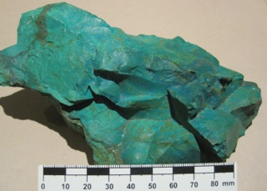 | 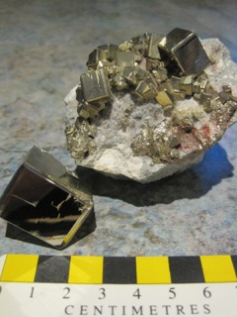
Chrysocolla (a secondary copper oxide),  Collahuasi Mine | Pyrite (a primary sulphide),  El Teniente Mine

